**Data Acquisition and Exploration:**

Objective: To verify the successful acquisition of provided data for doctor ratings on RateMDs.

Test Procedure:

Verify that the provided data sources for doctor ratings on RateMDs have been obtained.

Confirm the completeness and integrity of the acquired data.

Expected Result: The system should have access to the required data sources without any errors.

Result:

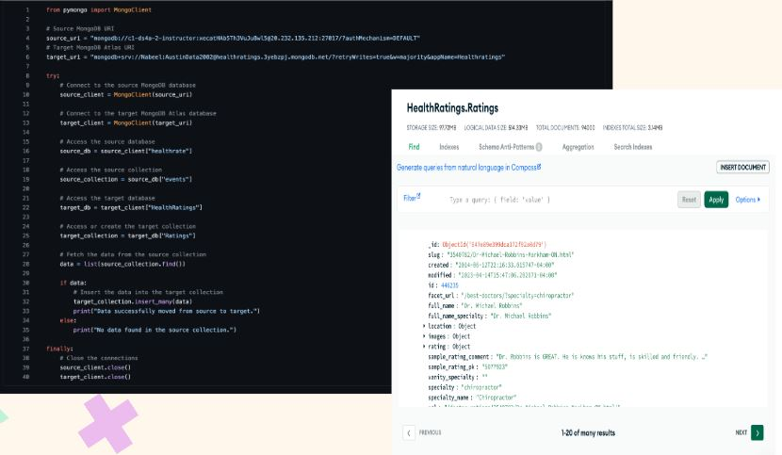

**Data Profiling:**

Objective: To assess the quality, structure, and completeness of the acquired data.

Test Procedure:

Analyze the data to identify any anomalies, such as missing values, duplicates, or inconsistencies.

Document metadata including data types, field names, and descriptions.

Expected Result: The data should be well-structured, complete, and consistent for further processing.

**Data Cleaning and Preprocessing:**

Objective: To ensure that the data is cleansed and prepared for integration.

Test Procedure:

Implement procedures to handle missing values, duplicates, and inconsistencies.

Normalize data formats to ensure consistency and compatibility.

Expected Result: The data should be cleaned and preprocessed to facilitate seamless integration and analysis.

Result:

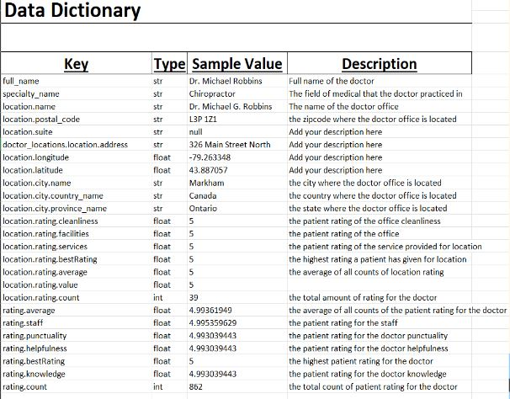

**Dimensional Modeling:**

Identify Dimensions and Facts:

Objective: To define key dimensions and facts and design a star schema with DbSchema.

Test Procedure:

Identify relevant dimensions and facts based on the business requirements.

Verify that key entities such as doctors, and ratings are appropriately defined.

Expected Result: Key dimensions and facts should be identified in accordance with the business requirements. Star schema is created to structure a system data warehouse.

Result:

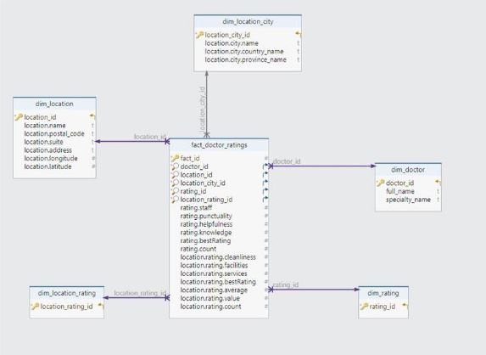

**Data Storage and Processing:**

Choose Data Storage Solutions:

Objective: To select appropriate databases for storing the data.

Test Procedure:

Utilize MongoDB for storage.

Expected Result: The selected data storage solutions should meet the system's requirements and support scalability.

**Implement ETL Processes:**

Objective: Extraction, transformation, and loading of data.

Test Procedure:

Utilize Alteryx to extract data from the source, transform it according to the dimensional model, and load it into the data warehouse.

Expected Result: ETL processes should be implemented successfully, ensuring the timely and accurate loading of data into the data warehouse.

Result:

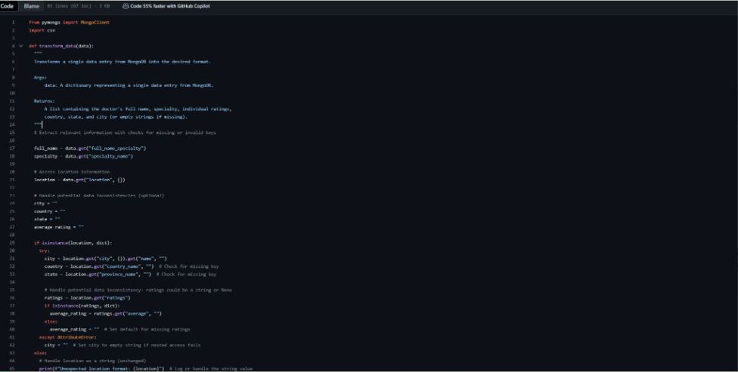

**Data Visualization and Analysis:**

Choose Visualization Tools:

Objective: To select appropriate visualization tools for creating dashboards and reports.

Test Procedure:

Utilized DOMO software for visualization.

Verify compatibility and ease of use for creating interactive visualizations.

Expected Result: The visualization tools should meet the system's requirements and enable the creation of interactive and insightful dashboards.

**Design Dashboards and Reports:**

Objective: To develop interactive visualizations and enable filtering and drill-down capabilities.

Test Procedure:

Design dashboards and reports using the selected visualization tools.

Ensure that visualizations are interactive and allow users to filter and drill down into the data.

Expected Result: Dashboards and reports should be visually appealing, interactive, and provide actionable insights for users.

Result:

